References and Copyrights

This chapter contains references to the information sources which were used to create the material.
1) Peter Eeles. Capturing Architectural Requirements
http://www.ibm.com/developerworks/rational/library/4706.html

2) Rational Unified Process® Version 7.0.1

There are few illustrations in the form of diagrams, tables and pictures in this document. These examples do not contain any commercial or technological information and are used only as illustrations to main ideas.

How to use Architectural Mechanisms to elicit architectural requirements

Architectural Mechanism is the common solution for the frequently appeared problem.(pattern).
There are 3 kind of the Architectural Mechanisms:
- Analysis Mechanism;
- Design Mechanism;
- Implementation Mechanism.

Figure 1. shows how Architectural Mechanisms are related to requirements and development phases by RUP®.

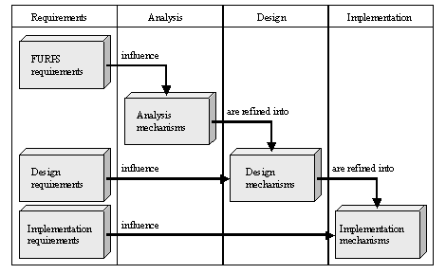
Figure 1.

Analysis Mechanism
This mechanism is to analyze architecture regardless of realization. In the table below you may see the examples of Analysis Mechanisms.

Analysis Mechanism | Design Mechanism | Implementation Mechanism
Persistence | RDBMS | Microsoft SQL Server
Persistence | RDBMS | Interbase  Oracle
Persistence | OODBMS | ObjectStore  Oracle
Communication | Object request broker | Orbix
Communication | Object request broker | VisiBroker
Communication | Message queue | MSMQ
Communication | Message queue | MQSeries

More detailed examples of analysis mechanisms you may find out in the “Analysis Mechanisms Examples” chapter.

Design Mechanism
It is specified and more precise Analysis Mechanism. It’s encapsulated the implementation environment factors. As an example here goes Enterprise Patterns, DataBase design methods.

A design mechanism is a refinement of an analysis mechanism. It assumes some details of the implementation environment but is not tied to a specific implementation. In our example, the communication analysis mechanism may be realized as a design mechanism such as an object request broker or a message queue.

Implementation Mechanism
It’s the realization of Design Mechanism.
An implementation mechanism is a refinement of a design mechanism, and specifies the exact implementation of the mechanism. For example, an object request broker may be implemented using either Orbix or VisiBroker.

Analysis Mechanisms Examples
Examples below are got from the article [1].
Analysis Mechanism | Description
Auditing | Provides audit trails of system execution.
Communication | Allows distributed processes to communicate.
Debugging | Provides elements to support application debugging.
Error Management | Allows errors to be detected, propagated, and reported.
Event Management | Supports the use of asynchronous messages within a system.
File Management | Provides services for accessing a file system.
Graphics | Supports user interface services, such as 3D rendering.
Information Exchange | Supports data format conversion.
Licensing | Provides services for acquiring, installing, tracking, and monitoring license usage.
Localization | Provides facilities for supporting multiple human languages.
Mail | Services that allow applications to send and receive mail.
Mega-data | Support for handling large amounts of data in a client-server environment.
Memory Management | Services for abstracting how memory is allocated and freed.
Meta-data | Supports the runtime introspection of components.
Online help | Provides online help capability.
Persistence | Services to manipulate persistent data.
Printing | Provides facilities for printing.
Process Management | Provides support for the management of processes and threads.
Reporting | Provides reporting facilities.
Resource Management | Provides support for the management of expensive resources, such as database connections. Provides support for the management of expensive resources, such as database connections.
Scheduling | Provides scheduling capability.
Security | Provides services to protect access to certain resources or information.
System Management | Services that facilitate management of applications in a distributed environment.
Time | Services to synchronize time on a network, and to translate times into different time zones.
Transaction Management | A mechanism for handling ACID ¹ transactions.
Workflow | Support for the movement of documents and other items of work, typically through an organization.

Lessons Learned and Best Practices of Architectural Mechanisms design and implementation in project “ZZZ”

Architectural Mechanisms Discovering
The Architectural Mechanisms were being discovered and discussed during architectural meetings while all the architectural significant stakeholders’ requests were being presented by system analyst and refined by architectural team, and while the questions of architectural requirements management were being resolved. You may see SADD-MTHD-02-Architectural Requirements.doc to know how to develop and manage architectural requirements.

In the particular project there were 44 architectural mechanisms discovered, 2 of them were rejected later.

All the discovered architectural mechanisms were placed in the special list of architectural mechanisms. See embedded object below to study this list.

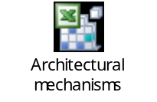
This list were revisited many times iteratively, especially while brainstorming the particular architectural mechanism. It’s also were refined during architectural mechanisms analysis.

Architectural Mechanisms Model Design
The architectural mechanisms model was created in Rational Rose tool for visual modeling, though you may use any other tool suitable for this. This model is designed as set of diagrams where control entities and their dependencies are shown.

Every diagram shows or the whole architectural mechanism or its part:
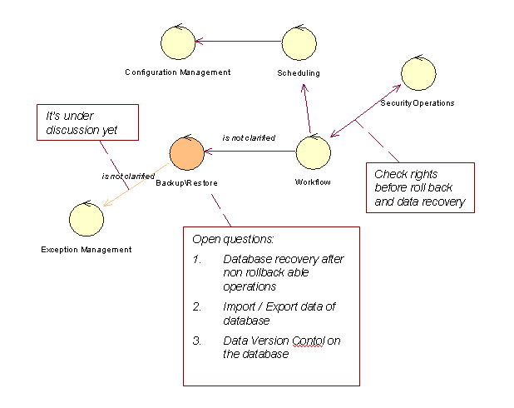

Architectural Mechanisms Development methods
- Define success criteria of the architectural mechanism realization.

During definition of this criteria it’s recommended to pay special attention to such quality attributes (non-functional requirements) as: productivity, scalability, multyuser mode, system deployment scenarios.
The success criteria must be continuously refined while this one architectural mechanism is being developed and while the other ones are being designed and developed, to incorporate every new assumption and restriction appeared.

- Develop architectural mechanism test scenarios to be sure that we implemented as the architectural mechanism exactly what we had and want to. You may see SADD-MTHD-05-Architecture Testing.doc to know how to do this.

- Create clear and unified vision in the architectural team how this architectural mechanism will be distributed by layers.

It’s necessary to study the problem from the Software Architect point of view, to detect application layer (data acess layer (DAL), business layer (BL), user interface layer (UI), where this architectural mechanism will work.
Then make a decision,to realize architectural mechanism on Client or Server side from the System Architect perspective. Consider and discuss all the possible ways of system deployment.

- Define every characteristic of the architectural mechanism in details.

- Analyse every relation (dependency) of the architectural mechanisms. When we say ”А is used В” or “A is depends on B”). We strongly recommend you to use special modeling tools to design Sequence Diagrams и other diagrams.

- Complete architectural significant stakeholder requests related to developed architectural mechanism analysis to find out all the architectural restrictions and the most important architectural requirements.

- Describe data structures of the developed architectural mechanism

- Pay special attention to interfaces with outer software and systems. Detect all the needs to use any other software and system for the developed architectural mechanism to work.

- Specify every exceptions for the architectural mechanism. Create list of exceptions to be caught and processed

- Finalyse architectural requirements (processing speed, productivity, data sending / receiving speed and the capacity of the transmission / data transfer channel. etc.)

The result of architecture mechanism is the Logical and Component models. Have a look to SADD-MTHD-04-Analysis and Modelling.ppt to understand exactly what do we mean for the meaning and the purpose of these models. Please, note, that this result is not the result of SADD iteration. During single iteration the same architectural mechanism could be iteratively chaned and developed few times for the different reasons.

That’s why it’s very important to design and develop architectural mechanisms simultaneously and iteratively to make sure that all the mechanisms are designed and developed as the entire and integral architectural ensemble.

Conclusion
Architector team must clearly understand and to have unified vision of:
- how architectural mechanism uses and is used by other mechanisms;
- how it uses and is used by other systems and software;
- which data it is used and how it work with these data
- interconnection protocols
- security protocols

The process of architectural mechanism design and development is iterative. By the end of every iteration we get models and prototypes which are consistently précised during the next iterations so as the architectural mechanism success criteria and characteristics are constantly refined and implemented too.

